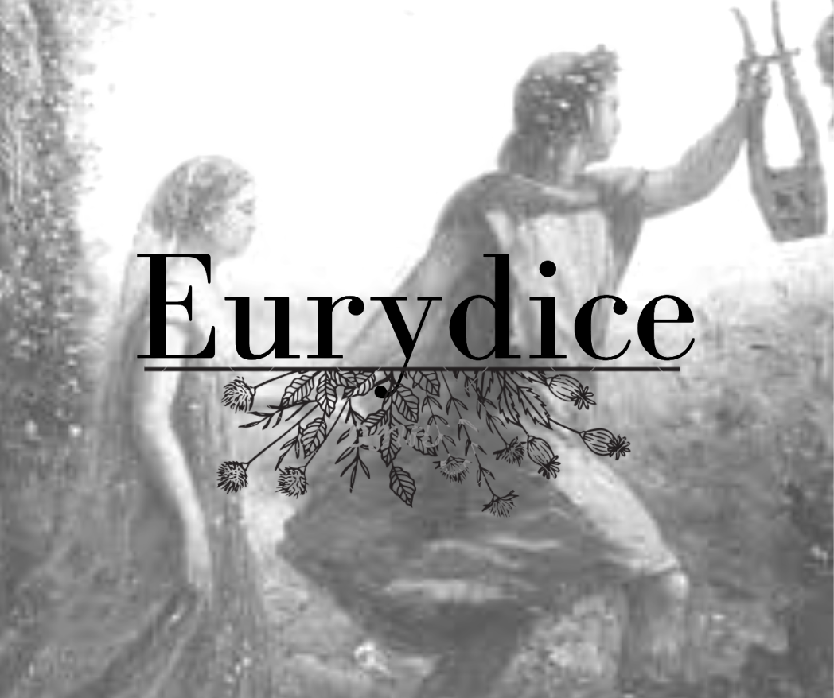
Kendra Comstock, soprano

Na’ama Lion, baroque flute
Andrew Koutroubas, baroque cello
David Mather, baritone
Job Salazar Fonesca, baroque violin
Angie Tyler, soprano
Mo-Ah Kim, harpsichord

A Graduate Vocal Recital
7:30pm April 24th, 2021
Longy School of Music
Cambridge, MA

Cara e amabile catena Antonio Sartorio (1630-1680)
Rosa del Ciel/ Io non dirò Claudio Monteverdi (1567-1643)
Mio ben, teco il tormento Luigi Rossi (1597-1653)
Soutiens moi chère Enone Marc-Antoine Charpentier (1643-1704)
Orfeo, tu dormi? / Se desti pietà Antonio Sartorio (1630-1680)

Orphée Louis-Nicolas Clérambault (1676-1749)
Numi, che veggio Antonio Sartorio (1630-1680)
Mit dir mich zu ergetzen Georg Philipp Telemann (1681-1767)
Qual vita è questa mai/ Che fiero momento Christoph Willibald Gluck (1714-1787)
Vous partez donc Orphée? Marc-Antoine Charpentier (1643-1704)

Program Notes and the Orpheus Myth
The myth of Orpheus and Eurydice begins and ends with tragedy. In Greek mythology Orpheus is regarded as the world’s greatest musician, who could make the rocks and trees move with the sound of his voice or the strike of his lyre. On Orpheus and Eurydice’s wedding day, Eurydice is bitten by a snake and dies. The myth states that Orpheus then traveled to the Underworld to plead for Pluto to release Eurydice. Pluto agrees with the stipulation that Orpheus must lead Eurydice back to the mortal world without looking at her. When they leave the Underworld, at the threshold of the mortal realm, Orpheus turns to gaze at Eurydice, banishing her to the Underworld forever. This myth has intrigued composers throughout history and even day. The myth stays relevant not because of its tragedy, but because of its mystery, as generations attempt to understand Orpheus’ state of mind. Why did Orpheus turn around when he knew the consequence? Was he unable to resist the cries of his love? Or did he travel to the Underworld to lose her a second time as inspiration for his plaintive music? There is no certain conclusion.
However, it was not Orpheus’ journey that drew me to this myth, but Eurydice’s. In this story she is left to suffer for Orpheus’ actions. Did she feel betrayed? Did she even want to be saved? Often Eurydice serves only as a cause for Orpheus’ quest. Orpheus is given a voice, while Eurydice remains silent. This program was created by combining pieces from several Orphean operas to show many interpretations of the myth: L’Orfeo (1607, Monteverdi); Orfeo (1647, Rossi); L’Orfeo (1672, Sartorio); La descente d'Orphée aux enfers (1686, Charpentier); Orpheus (1726, Telemann); Orfeo ed Euridice (1762, Gluck); and one cantata, Orphée (1710, Clérambault). As the myth unfolds in this program, I ask you to consider your own interpretation of Orpheus’ actions. Consider the love of an artist and consider his love. But also consider Eurydice. As I prepared for this performance, I strived to embody every version of Eurydice’s story. Eurydice will finally have her voice.
Many thanks Pamela Dellal, John McKean, Vivian Montgomery, Billy Jewell, Corinne Byrne, and the students, faculty, and staff at the Longy School of Music that made this performance possible.

Translations
Orpheus and Eurydice
Cara e amabile catena Cherished bond of love
Che mi stringe al mio tesoro that binds me to my dearest
Che m’unisce al ben ch’adoro that unites me with the one I adore.
Imeneo fausto e felice. Happy and auspicious marriage.
Son d’Orfeo. Lieta godo. I am Orpheus’s. I am filled with joy.
Io d’Euridice. Si bel nodo And I am Eurydice’s. A knot so gentle
Radolcisce ogni mia pena. Soothes every pain.
Translation © Erato - La storia di Orfeo*
Orpheus
Rosa del Ciel, vita del mondo e degna Rose of Heaven, life of the world, and worthy
Prole di lui che l’universo affrena son of him who curbs the universe,
Sol che ’l tutto circondi e ’l tutto miri, great Sun, all-encompassing and all-beholding,
De gli stellanti giri, tell me, have you ever seen,
Dimmi: vedesti mai from the starry orbits
Di me più lieto e fortunato amante? A lover happier or more blessed than I?

Fu ben felice il giorno, Happy was the day,
mio ben, che pria ti vidi, my love, when first I saw you,
e più felice l’ora and happier the hour
Che per te sospirai, I sighed for you,
Poich’al mio sospirar tu sospirasti: because my sighs found echo in your own;
Felicissimo il punto happiest of all the moment
Che la candida mano when you offered your white hand to me
Pegno di pura fede a me porgesti. As ledge of purest faith.
Se tanti cori avessi Had I as many hearts
Quant’occhi ha il Ciel eterno, e quanto chiome as the eternal has stars and these fair hills
Han questi colli ameni il verde maggio, have leaves in the verdant month of May,
Tutti colmi sarieno e traboccanti all would be full and running over
Di quel piacer ch’oggi mi fa contento. With the joy that now makes me content.
Translation © Erato - La storia di Orfeo
Eurydice
Io non dirò qual sia I cannot express the joy
Nel tuo gioir, Orfeo, lagioia mia, your joy, Orpheus, inspires in me,
Che non ho meco il core, since my heart is not with me
Ma teco stassi in compagnia d’Amore; but with you, companioned by Love,
Chiedilo dunque a lui s’intender brami Ask him, therefore, if you long to know
Quanto lieto gioisca, e quanto t’ami. How it rejoices and how much it loves you.
Translation © Erato - La storia di Orfeo*

Eurydice
Mio ben, teco il tormento Beloved, with you
Più dolce il troverei torment would be far sweeter
Che con altri il contento than contentment with another.
Ogni dolcezzo è sol dove tu sei, Every sweetness lies only with you,
E per me Amor aduna and Love has gathered every happiness
Nel girar de’ tuoi sguardi ogni fortuna. For me in your glances.
Translation © Erato - La storia di Orfeo*
Eurydice
Soutiens moy chere Enone Support me my dear Enone,
un serpent ma blesse, a snake has bitten me,
Je n’en puis plus je tombe et du venin pressee I cannot go on, I am falling, prey to its poison.
Orphee, adieu, je meurs Orpheus, farewell, I am dying.
Translation © Stewart Spencer (W. C. France)
Eurydice
Orfeo tu dormi? E ne gl’Abissi oscuri Orpheus, are you sleeping? Can you forsake
Lasci Euridice, e l’amor suo ti scordi? Eurydice in the dark abyss and forget her love?
Così a la lira il dolce canto accordi, Can you sweetly sing to the sound of your lyre
E dal regno infernal trarmi non curi? And not think of saving me from Hades?

Se desti pietà, ne’ tronchi e ne’ stassi, You whose song moves the trees and the rocks,
Volgendo anco i passi nel regno del pianto, make your way now to the realm of tears
Là pur il tuo canto pietà troverà and there too inspire pity with your song.
Translation © Erato - La storia di Orfeo*
Orpheus
Orfée
Le fameux Chantre de la Thrace The famous singer from Thrace,
Par les regrets les plus touchants, With the most touching sorrows,
Par les plus tendres chants With the most tender songs,
Déplorait ainsi sa disgrâce: Lamented thus his misfortune:
Fidèles échos de ces bois Faithful echoes of these woods,
Cessez de répondre à ma voix. stop responding to my voice!
Rien ne peut soulager la douleur qui me presse, Nothing can ease the grief which seizes me,
Je ne reverrai plus l'objet de ma tendresse. I will never see again the object of my affection.
Fût-il jamais amant plus malheureux? Was there ever a lover more wretched?
Fût-il jamais un destin plus barbare? Was there ever a fate more monstrous?
Le tendre Amour nous unissait tous deux, Tender love united us both,
La mort cruelle nous sépare. cruel death separates us.
Fidèles échos... Faithful echoes...

Mais que sert à mon désespoir But how can constant moaning
de gémir et me plaindre encore? and lamenting be of use to my despair?
Pluton retient les charmes que j'adore. Pluto possesses the charms that I adore.
Allons implorer son pouvoir. Let's go petition his power.
Ce gouffre obscur m'offre un passage This murky cavern offers a passageway
Pour pénétrer aux sombres bords. to penetrate the dark depths.
Portons y mon amour, We'll bring along my love,
ma douleur et ma rage. my grief, and my rage.
Ramenons Euridice, We'll bring back Euridice,
ou restons chez les morts. or remain with the dead.
Allez Orphée, allez, que votre amour extrême Go forth, Orpheus, go, for your extreme love
Serve d’exemple à l’univers. Serves as an example to the universe.
Il est beau qu’un mortel passe jusqu’aux Enfers It is a fair thing for a mortal to pass over to Hell
Pour se rejoinder à ce qu’il aime. In order to reunite with her he loves.
Hâtez-vous, genereux amant, Hasten, generous lover,
Votre amour sert à votre gloire. Your love will enhance your glory.
L’avenir aura peine à croire Posterity will scarcely believe
Qu’on ait aimé si constamment. That someone could love so devotedly.
Une tendresse conjugale A conjugal affection
N’a point encore forcé d’epoux Has never yet driven a husband
A passer la Barque fatale, To cross upon fatal ferry,
Cet honneur n'etait du qu' a vous. This honor belongs to you alone.
Cependant le Heros arrive Meanwhile the hero reaches
Sur l'infernale rive, The infernal shore,
Et malgré les loix d'Atrapos, And in defiance of Atropos’ strictures,
Au fier Dieu des Enfers He addresses these words
il adresse ces mots: to the proud God of Hell:
Monarque redouté de ces Royaumes sombres, Dread Monarch of these somber realms,
Je suis le Fils du Dieu du Jour I am the son of the God of Day;
Plus malheureux cent fois A hundred times more wretched
que vos plus tristes ombres. than your most unhappy shades.
Et mon malheur est causé par l'amour. And my misery is caused by love.
Vous voyez un amant fidèle You see a faithful lover
Prive du seul objet qui l'avait enflamme. Deprived of the sole object that set him aflame.
Hélas! le bonheur d'être aimé Alas! The delight of being loved
Rend ma peine encore plus cruelle! Makes my pain even more cruel!
Laissez-vous toucher par mes pleurs. Allow yourself to be moved by my tears.
D'un sort affreux reparez le caprice, Correct the whim of a frightful fate;
Rendez-vous ma chère Euridice, Return my dear Euridice,
Ne séparez pas nos deux coeurs. Do not separate our two hearts.
Vous avez ressenti la flamme You have felt the fire
Du Dieu dont j'éprouve les traits. Of that god whose effects I demonstrate.
L’aimable fille de Cérès The lovely daughter of Ceres,
Par ses divins appas With her divine charms,
sçut embrazer votre âme. could ignite your soul.
Laissez-vous, etc. Allow yourself, etc…

Pluton surpris d'entendre des accents Pluto, astonished to hear such strains
Capables d'émouvoir tout l'empire des morts. capable of touching the entire realm of the dead:
Cesse de m'attendrir; que ta plainte finisse. "Stop softening me up; let your lament end!
Va, dangereux mortel, Go, dangerous mortal,
sauve-toi de ces lieux. save yourself from this place.
Va, ramène ton Euridice. Go, take your Euridice with you.
Mais avant que de voir la lumière des Cieux But until you behold the light of the heavens,
Evite l'éclat de ses yeux. avoid the brilliance of her eyes."

Chantez la victoire éclatante Sing the brilliant victory
Que remporte le tendre amour. which tender love has won!
Jusques dans le sombre séjour Even as far as that shadowy land
Sa flamme est triomphante. its flame is triumphant.
Translation © Pamela Dellal
Eurydice
Numi, che veggio, o caro, o caro sposo. O gods, what do I see? Me beloved husband.
Nel rimirar quell’adorato viso As I gaze again on the face I adore,
Questo Tartareo albergo the dread abyss of Tartarus
Per me si cangia in fortunato Eliso. Becomes for me happy Elysium.
Euridice. Euridice
Alma mia! My love!
Dove, o cara, dove sei? Where are you, beloved?
Del tuo piè seguo l’orme. I am close behind you.
Oh Dio, ti sento, Oh God, I can hear you,
Ne ti posso mirar, ahi, che tormento. But I cannot see you. Alas, what torture.

Non ti volger, caro bene, Do not look back, my love,
Sin ch’il piè non ti conduce until your feet have carried you
Dove il Ciel con aurea luce to where the golden light of heaven
Spira ai vivi aure serene. Breathes its gentle air among the living.
Non ti vulgar, caro bene. Do not look back, my love.

Troppo fiero è il mio martire, My pain is too much to bear,
Langue il cor in non verderti. My heart breaks because I cannot see you.
Io vorrei pur compiacerti, I would love to please you,
Ma mi sento, o Dio, morire. But, oh God, I feel I am dying.
Troppo fiero è il martire. My pain is too much to bear.
Translation © Erato - La storia di Orfeo*
Eurydice
Mit dir mich zu ergötzen To delight myself with you
ist einzig meine Lust. is my only pleasure.
Nichts, das dir gleich zu schätzen, My faithful heart knows nothing
ist meiner Treu bewusst. that can compare with you.
Translation © Pamela Dellal

Eurydice
Qual vita è questa mai, What life is this now
Che a vivere incomincio! which I am about to lead?
E qual funestro, And what fatal,
Terribile segreto terrible secret
Orfeo m’asconde! does Orpheus hide from me?
Perché piange, e s’affligge? Why does he weep and grieve?
Ah, non ancora troppo Ah, I am as yet unaccustomed
Avvezza aglia affanni, to the sorrows
Che soffrono i viventi, suffered by the living!
A si gran colpo Beneath so great a blow
Manca la mia costanza; my constancy fails,
Agli occhi miei the light fades
Si smarrisce la luce, before my eyes;
Oppresso in seno, my breath, locked in my bosom,
Mi diventa affannoso il respirar. becomes laboured.
Tremo, vacillo, I tremble, I sway
E sento fra l’anguiscia e il terrore and feel my heart wildly beating
Da un palpito crudel vibrarmi il core. with anguish and terror.
Translation © Nika Kožar+
Eurydice
Che fiero momento! Oh bitter moment!
Che barbara sorte! Oh cruel fate!
Passar dalla morte To pass from death
A tanto dolor! to such sorrow!
Avvezzo al contento I was used to the peace
D’un placido oblio, of a tranquil oblivion;
Fra queste tempeste but in these tempests
Si perde il mio cor. my heart is shattered.
Vacillo, tremo… I sway, I tremble ...
Translation © Nika Kožar+
Eurydice, Orpheus, Enone
Vous partez donc Orphee You are leaving then, Orpheus.
ah regrets superflus Ah! Futile regrets.
Soulagement trop court plaisirs trop peu durables Relief all too brief, Pleasures too fleeting,
Helas vous estes disparus Alas, you have parted
Come des songes agreables Like pleasant dreams.

Demeurez toujours avec nous Stay with us forever,
Charmante impression de cette voix touchante Beguiling impression of this touching voice
Qui nous ravit qui nous enchante That ravishes and enchants us.
Tant que nous garderons un souvenir si doux As long as we retain so sweet a memory
Le bonheur des Enfers rendra le ciel Jalous Heaven will surely envy Hades’ joy.
Translation © Stewart Spencer (W. C. France)
*Translation printed with the courtesy of the label Erato - Warner Classics for the CD of Philippe Jaroussky - La storia di Orfeo
+Reprinted with permission from the LiederNet Archive

